CPL Working Group

The College of Early Childhood Educators (CECE) has implemented requirements for Registered Early Childhood Educators (RECE) to maintain a Continuous Professional Learning (CPL) Portfolio. “The CPL program is a framework and formal process to help RECEs increase their knowledge and skills and ensure quality professional practice throughout their careers” (CECE, 2018).

To assist RECEs with this process, the TBDSSAB will host quarterly Working Groups to discuss the CPL program, work together on setting goals, and build our CPL portfolios. Please bring any documents you feel may be relevant to your CPL Portfolio.

Next Meeting Dates:

Wednesday, September 25th from 6:00-7:30PM
Little Lions Waldorf Child and Family Centre – 211 Clarke Street

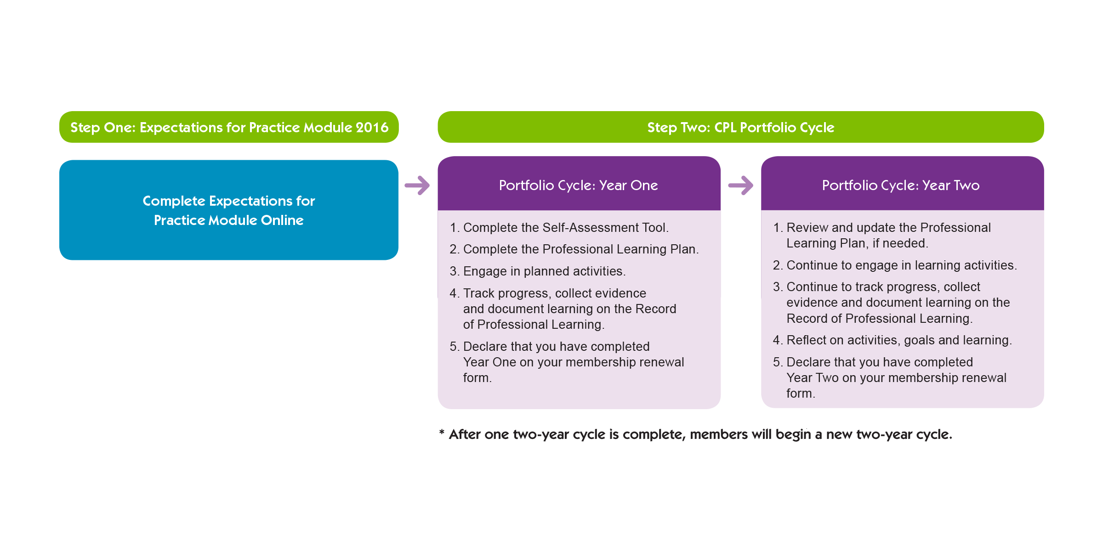
Thursday, December 5th from 6:00-7:30PM
Abiinojiishiik-amino-yawook EarlyON Centre – 325 Archibald Street (entrance off of Ridgeway Street)

For further information or to confirm your attendance to the CPL Working Group, please contact Jodi or Alexandria. Note that WebEx is available for all CPL Working Group meetings.
 | Jodi Corbett | Alexandria Malachowski
Call | (807) 766-4113 | (807) 766-4108
Text | (807) 630-1923 | (807) 630-0495
E-mail | Jodi.Corbett@tbdssab.ca | Alexandria.Malachowski@tbdssab.ca

