

**Yuck Science with Emily Kerton**

**October 25th, 2018**

**9:30 – 11:30am**

**Communities Together for Children**

We are excited to welcome Emily Kerton - Senior Scientist, Outreach and Indigenous Initiatives from Science North Thunder Bay to present this informative and interactive session.

Children *LOVE* getting their hands dirty and trying by doing. What better way to engage children in inquiry and science topics than by playing with dirt, slime, and other things that might make them say "yuck!" Yuck Science is a workshop designed to give educators the tools to get messy, learn some interesting science to share with the children, and keep the mess contained at the same time!

This session is recommended for Preschool and School Age educators, however all educators are welcome.

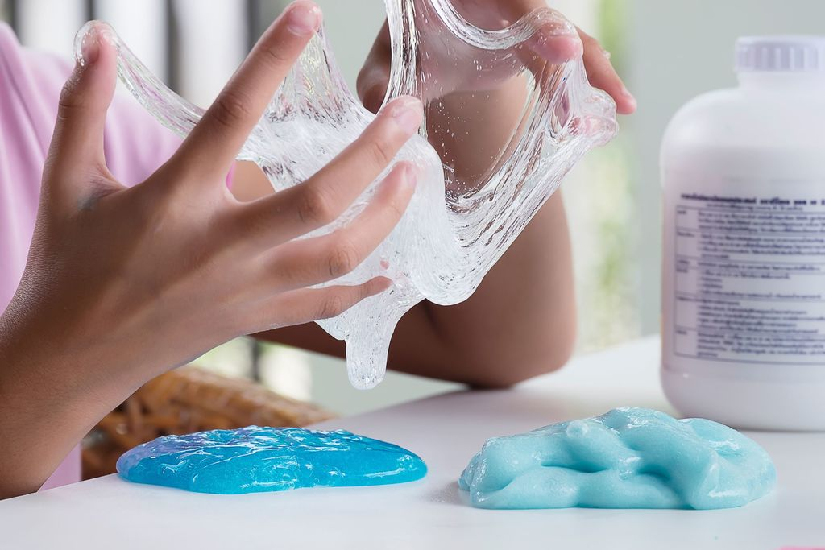

To register, please contact Jodi Corbett at 766-2111 x 4113 or by email at Jodi.Corbett@tbdssab.ca