Simplicity Parenting
with Kim John Payne
Using the extraordinary power of less to raise calmer, happier & more secure kids.

Little Lions Waldorf Child & Family Centre presents

THE OVERWHELM OF BOYS

Lecture: Tuesday, April 24th, 2018 from 7:00 – 9:00 pm

Faculty Lounge, Lakehead University

Join the board, staff and parents of Little Lions for this event.
Open to the General Public with a suggested donation of $10

Free child care is available on site. Please register for child care by calling 344-2298 Ext 4.

Copies of Simplicity Parenting will be available for purchase at the event.

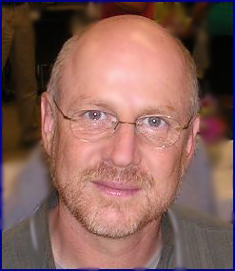
Kim John Payne, M.Ed.
“[Kim Payne] is like a master closet reorganizer for the soul.” - Time Magazine

A consultant and trainer to over 200 North American independent and public schools, Kim has been a school counselor, adult educator, consultant, researcher, educator and a private family counselor for nearly 30 years. He regularly gives key note addresses at international conferences for educators, parents, and therapists and runs workshops/training around the world.
Learn more at www.simplicityparenting.com.

