Crockpot Meals
(Cooks Session)
June 14th, 2018
6:30-8:30pm at Communities Together for Children

Join Megan Bellinger, Public Health Dietitian from the Thunder Bay District Health Unit, for a session on crockpot meals.
This session aims to spark some inspiration of crockpot meals you can try out in your centre, as well as other time saving tips in the kitchen and information on planning healthy meals.
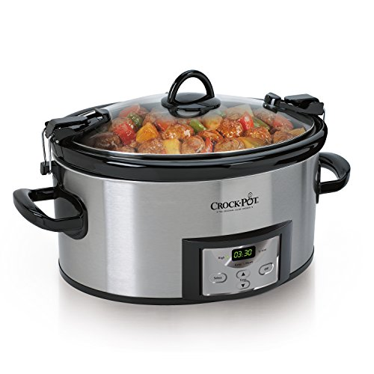
This will also be an opportunity to share ideas and network with cooks from other centres.

To register, contact Jodi Corbett:
Jodi.Corbett@tbdssab.ca | 766-2111 ext. 4113

