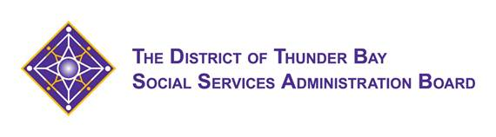



**The District of Thunder Bay Social Services Administration Board is pleased to announce information sessions from the College of Early Childhood Educators**

**Thursday April 26, 2018**

**7:00pm-9:00pm**

**DaVinci Centre**

**Understanding the Continuous Professional Learning Portfolio**

**To begin, you will consider and discuss key concepts of professionalism, the Code and Standards 2017 and the Continuous Professional Learning program. You will be guided through the CPL Portfolio Cycle, which is designed to facilitate reflection, planning, and engagement in your professional learning. Learn about how other RECEs are enhancing their practice through the CPL program. Reflect on how you will engage in this new program and how RECEs can support each other in professional learning.**

Please register by Friday April 20th to Michelle Wojciechowski at [michelle.wojciechowski@tbdssab.ca](mailto:michelle.wojciechowski@tbdssab.ca)

**Friday April 27, 2018**

**9am-10:30am**

**Communities Together For Children**

**(This session is limited to Child Care Supervisors, EarlyON Supervisors and School Principals)**

**Supporting the Profession**

**Please join us as we share regulatory and policy updates from the College of Early Childhood Educators. You will learn about the College’s mandate and governance structure. This presentation also addresses topics relevant to employers including the Code of Ethics and Standards of Practice, filing mandatory employer reports, the Continuous Professional Learning program and provides an overview of the College’s resources and publications.**

Please register by Friday April 20th to Michelle Wojciechowski at [michelle.wojciechowski@tbdssab.ca](mailto:michelle.wojciechowski@tbdssab.ca)