KITCHEN TOUR AT THE CHILDREN AND FAMILY CENTRE

When: JUNE 28 @ 1:15 PM - 2:15 PM

Where: Children and Family Centre
Please join us at the Children and Family Centre for a tour of Heather Conrad’s kitchen! Heather did a wonderful presentation for us at the Eat Local cooks session where she shared her knowledge and enthusiasm with us about preparing meals with local ingredients. This is a continuation of her presentation where we can visit her kitchen and be inspired by the tips, ideas, and strategies that Heather is using to make eating local possible for children.
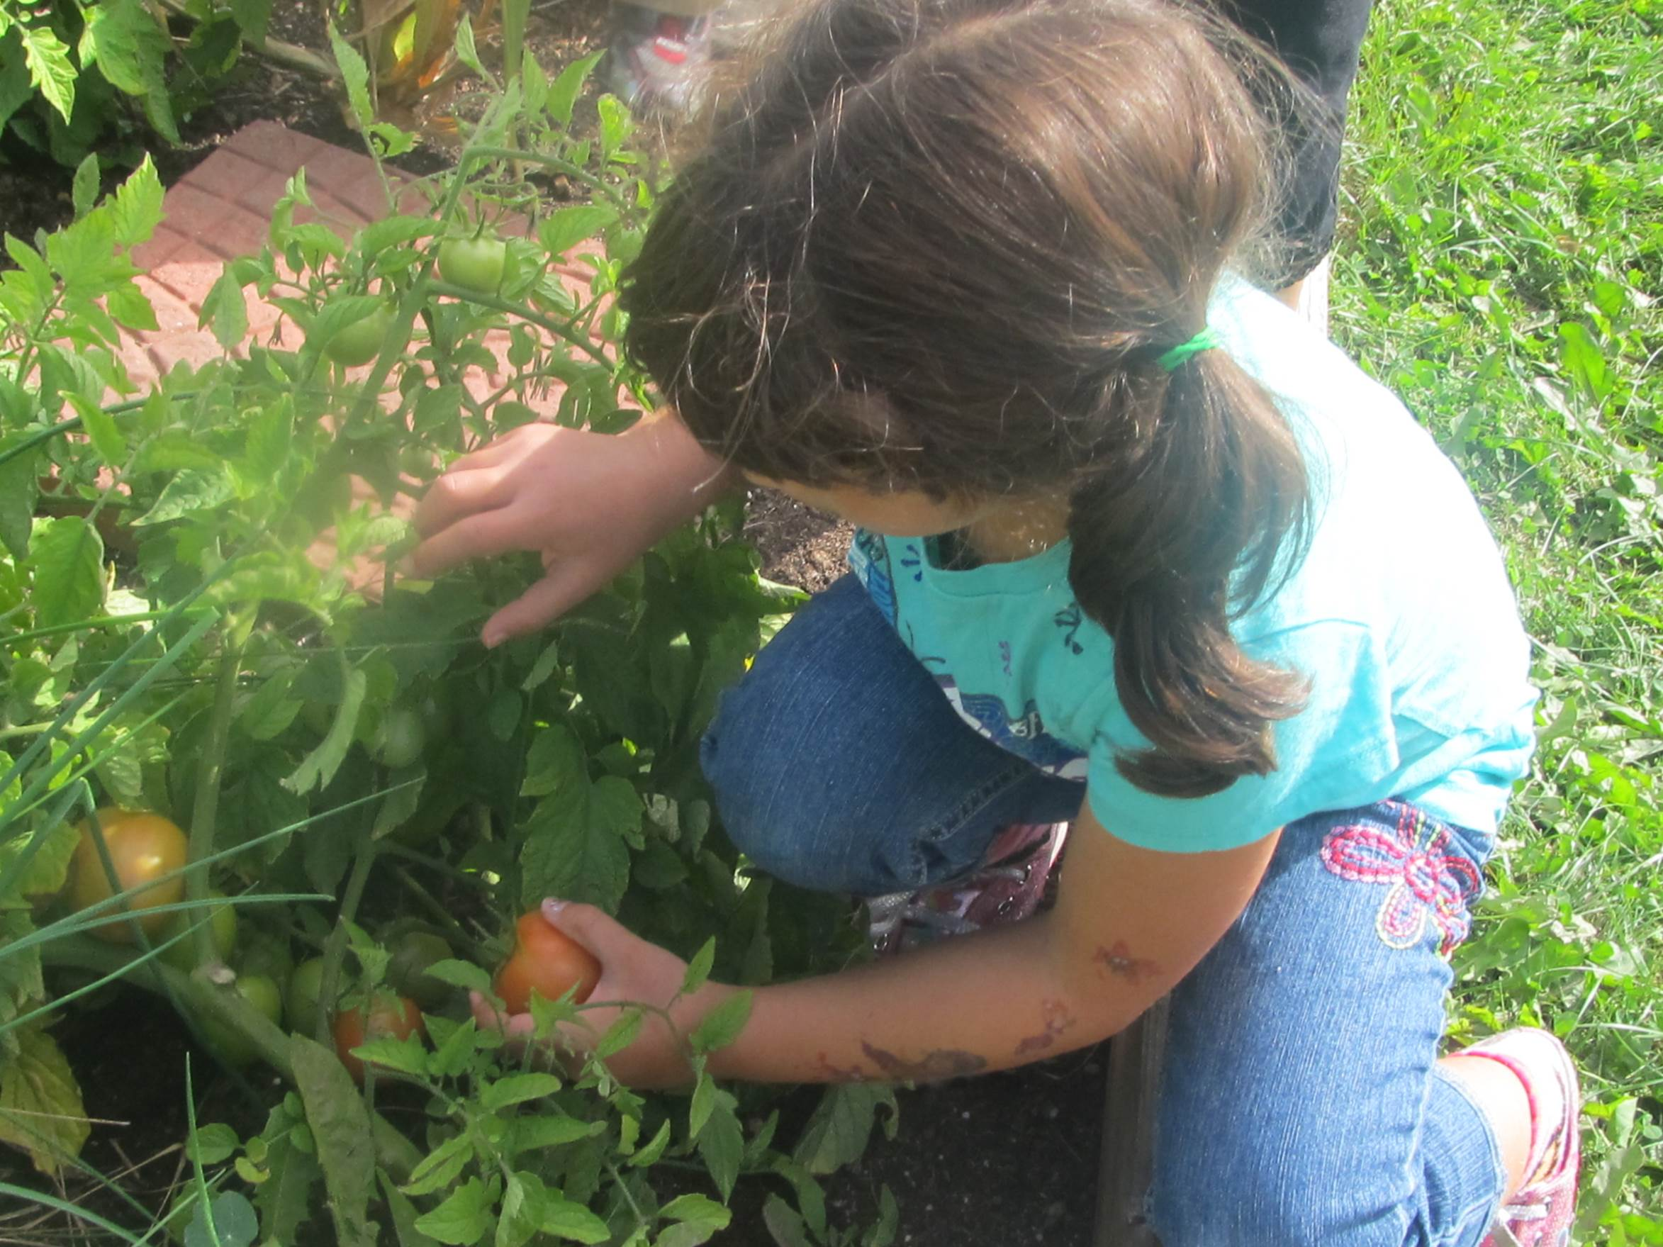
To register, contact Jenna Jenkins at Jenna.Jenkins@tbdssab.ca or call 766-2111 extension 4108.

